|  |
| --- |
| KITCHEN GARDEN MONITOR |
| TECH - FLEMING |

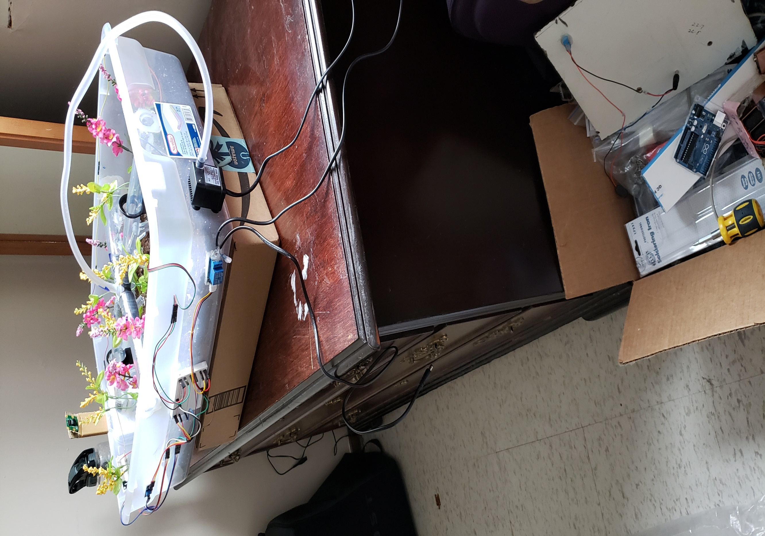

|  |
| --- |
| DHT22 Sensor |

* Image:

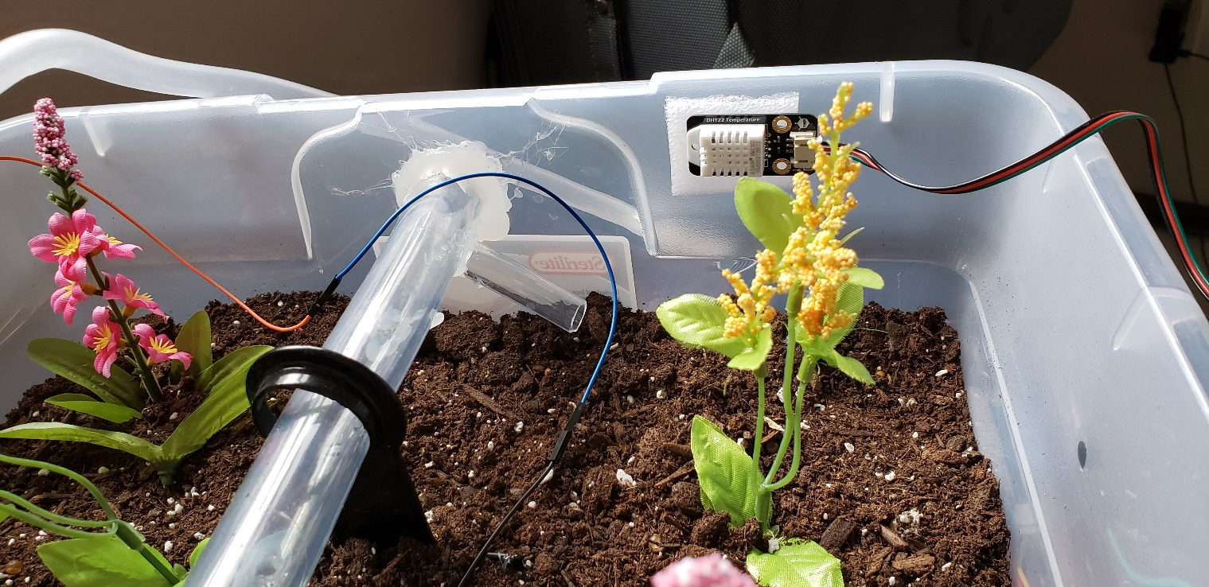

* Circuit Diagram:

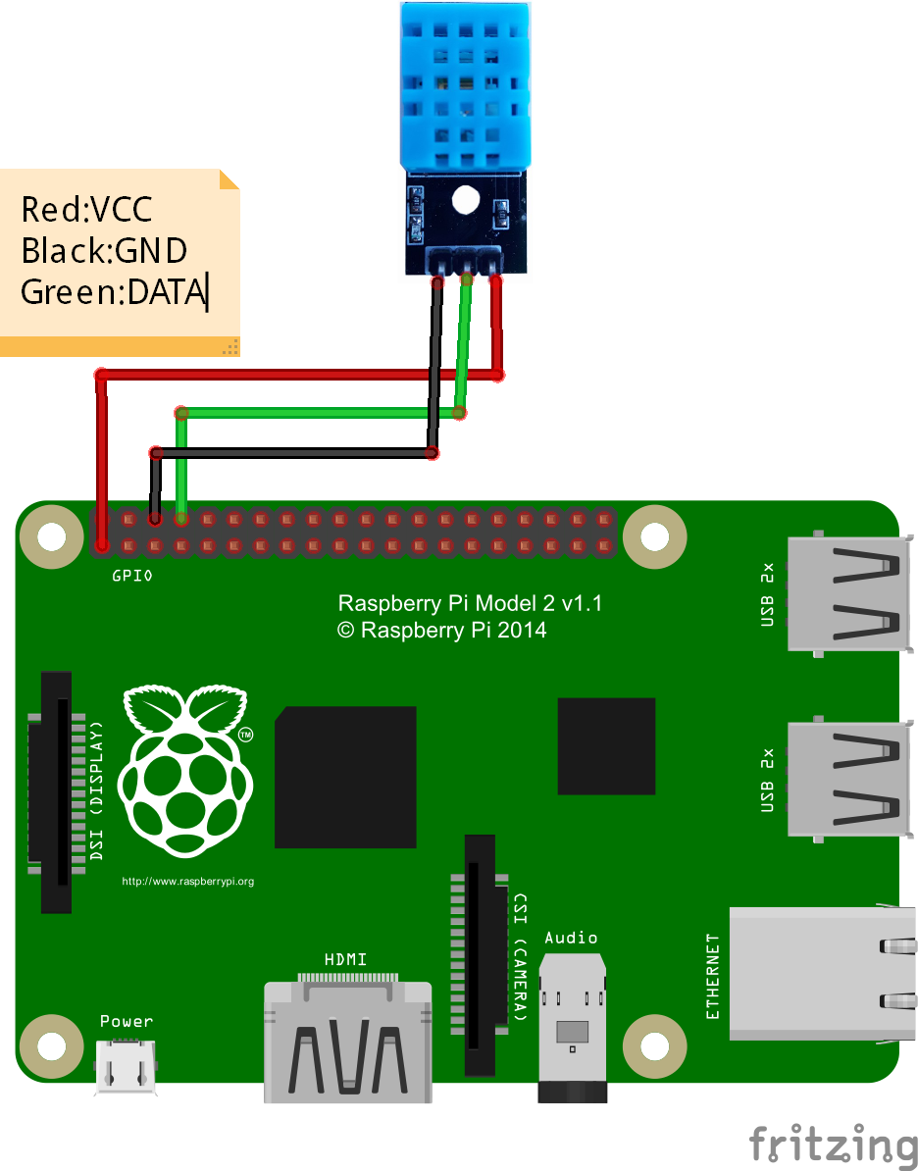

* DHT22 wiring diagram:

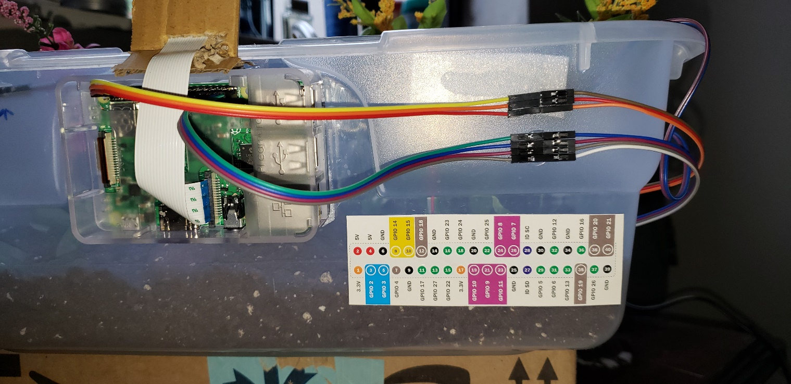

The 3 wires for the DHT22 sensor that are connected with Raspberry Pi are pin number:

1 for 5 volts 19 for the input signal

3 for ground

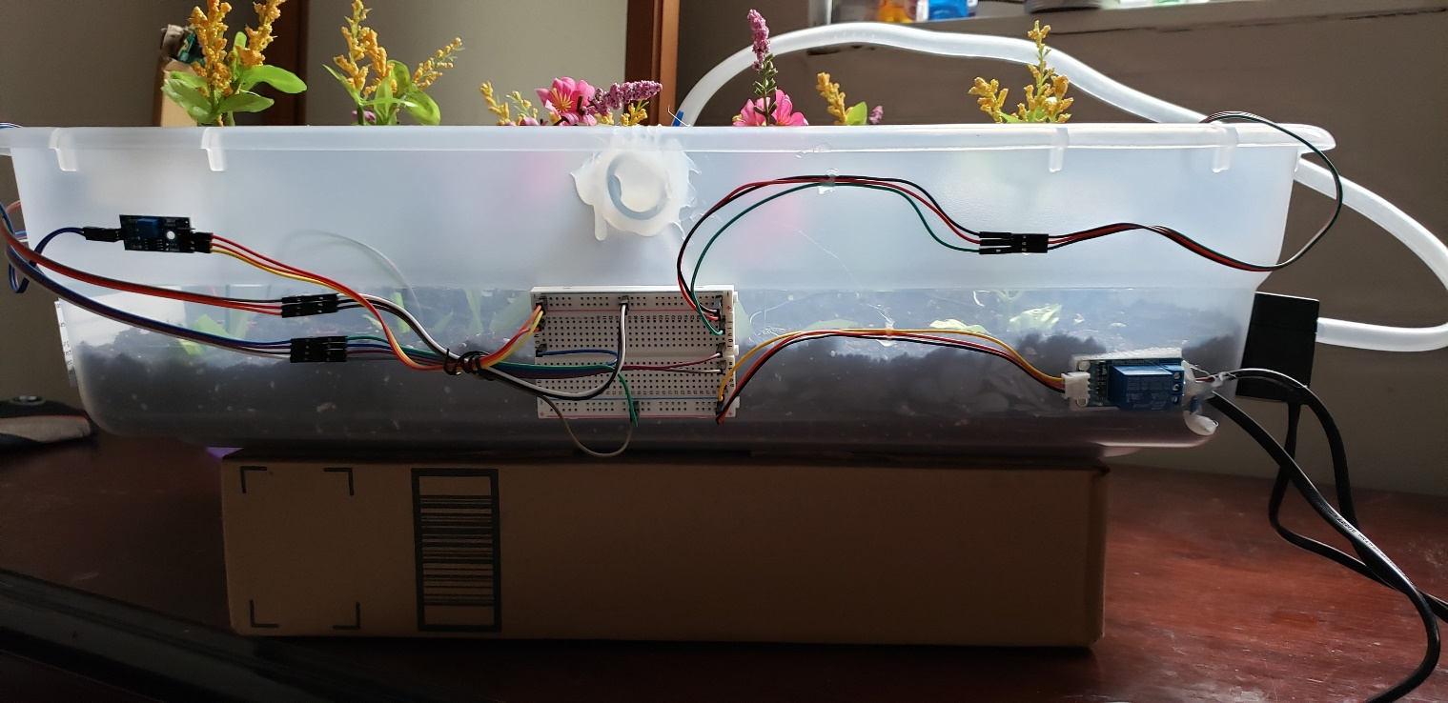

* Working:
  + DHT22 is an Air Humidity and Temperature sensor.
  + For the Humidity part, it consists of a component which is enclosed with the electrode and a moisture trapping substance sandwiched between them. When water molecule in air contact with the moisture trapping substance. It releases ions. Therefore,

Water Molecule ≈ Ions Released ≈ Low Resistance.

Lesser the resistance, more the conductivity, which gives you the corresponding value of humidity.

* + For Temperature part, it consists of a thermistor which changes its temperature with the change in temperature.

Temperature ≈ Decrease in resistivity ≈ Increase in Conductivity

Gives you the corresponding value of Temperature.

* Use of DHT22 in our project:
  + It helps in recording the Air Humidity and Temperature for our plants in the prototype box
  + Then, with the help of script this temperature and humidity is recorded in the Google Cloud Service Firebase database.
* Python Scripts:

Android App Screen Shots:

After gently touching the sensor value, you will get the second output which will give you more advanced graph to which you can compare your result and see weather your plants are in good condition or not.

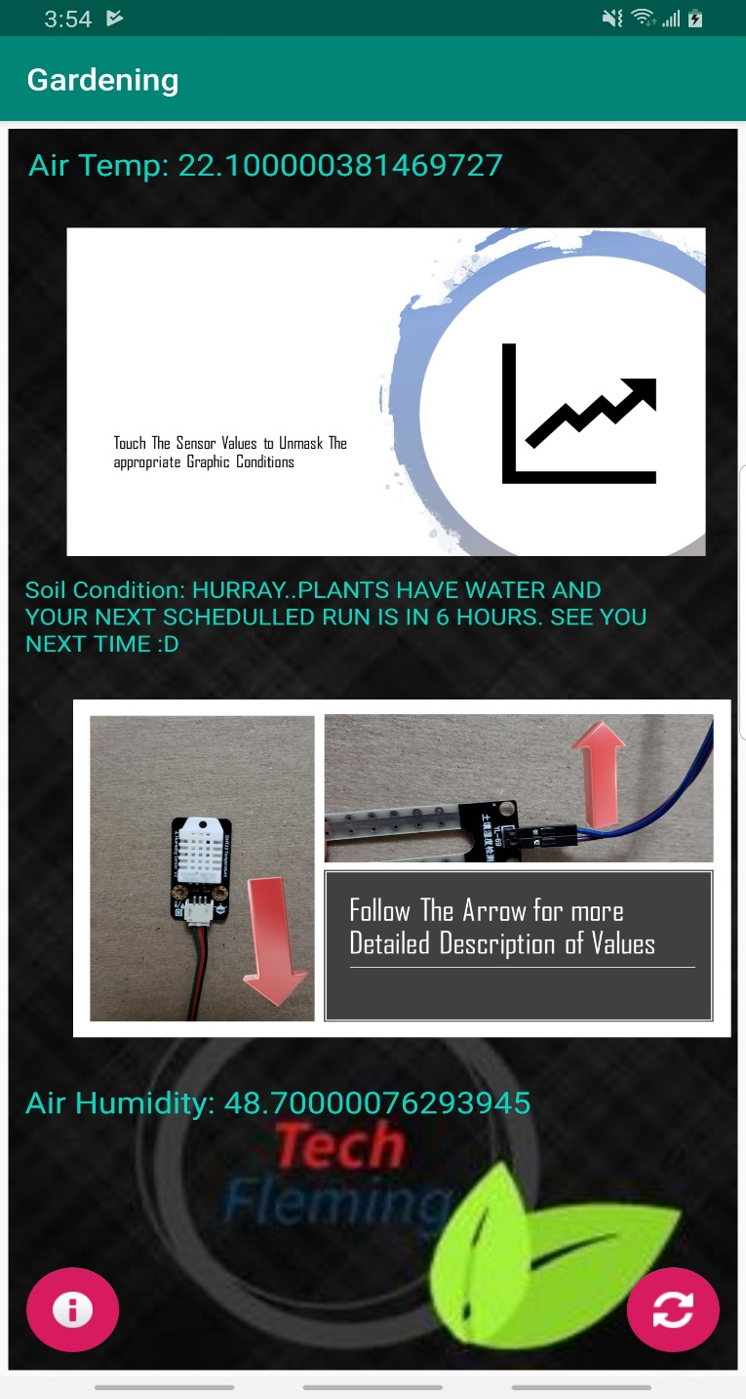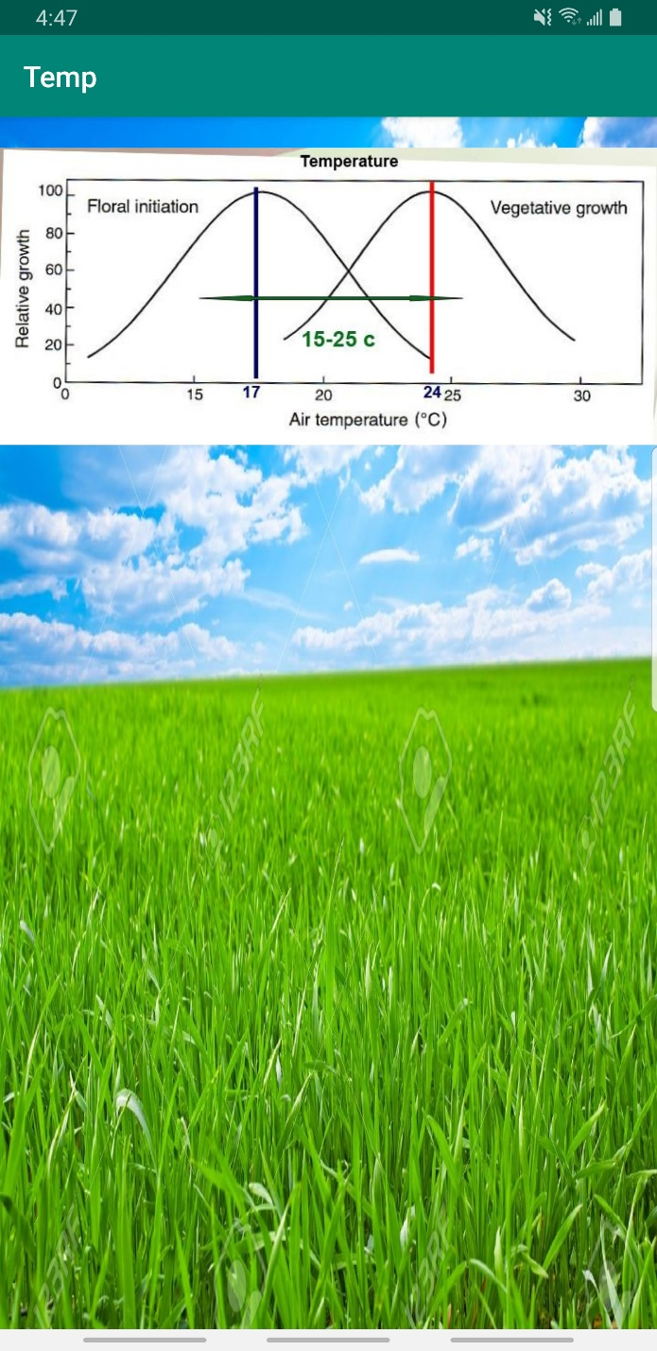

|  |
| --- |
| SOIL MOISTURE SENSOR |

* Image:

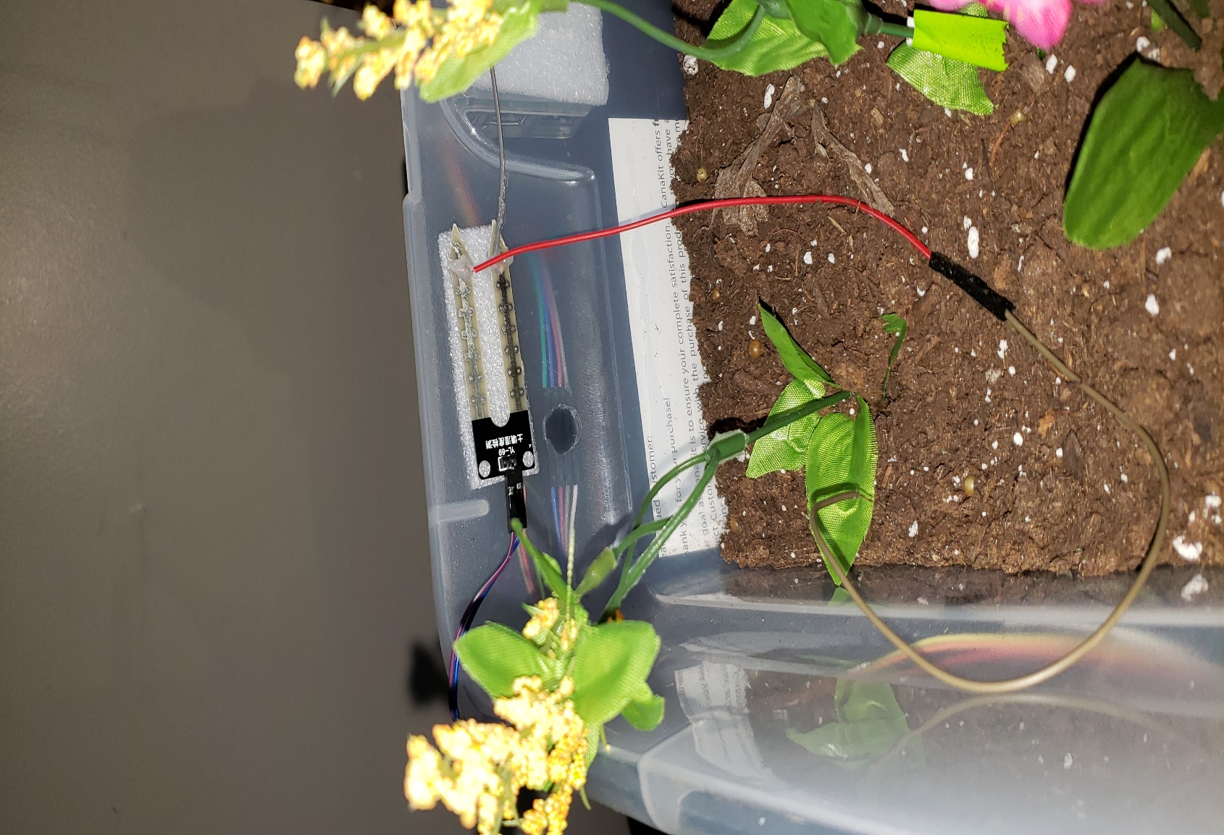

* Circuit Diagram:

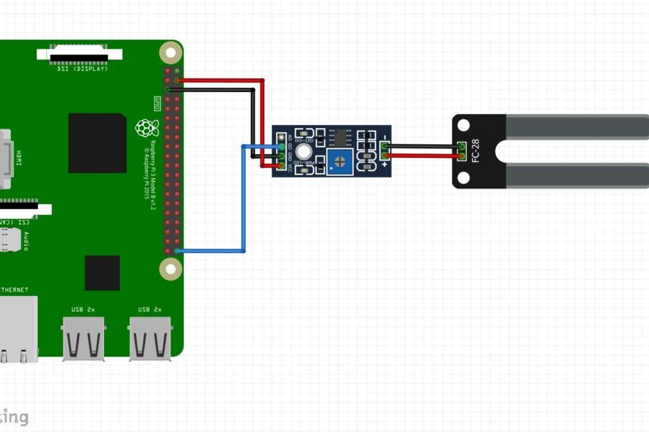

* Moisture Sensor Wiring Diagram:



The 3 wires for the Soil sensor that are connected with Raspberry Pi are pin number:

1 for 5 volts 37 i.e. GPIO 26 for the input signal

3 for ground



* Working:

This sensor works in a way that it measures the resistance between two tongs it has. The resistance between the two tongs decreases when it comes with the contact of water. Due to the water molecules, the conductivity between two tongs increases and sensor will tell you that the soil has sufficient water by lighting up the LED on the computation board.

Now, it has a computation board on which we can find a potentiometer. This meter can be turn to increase or decrease the conductivity.

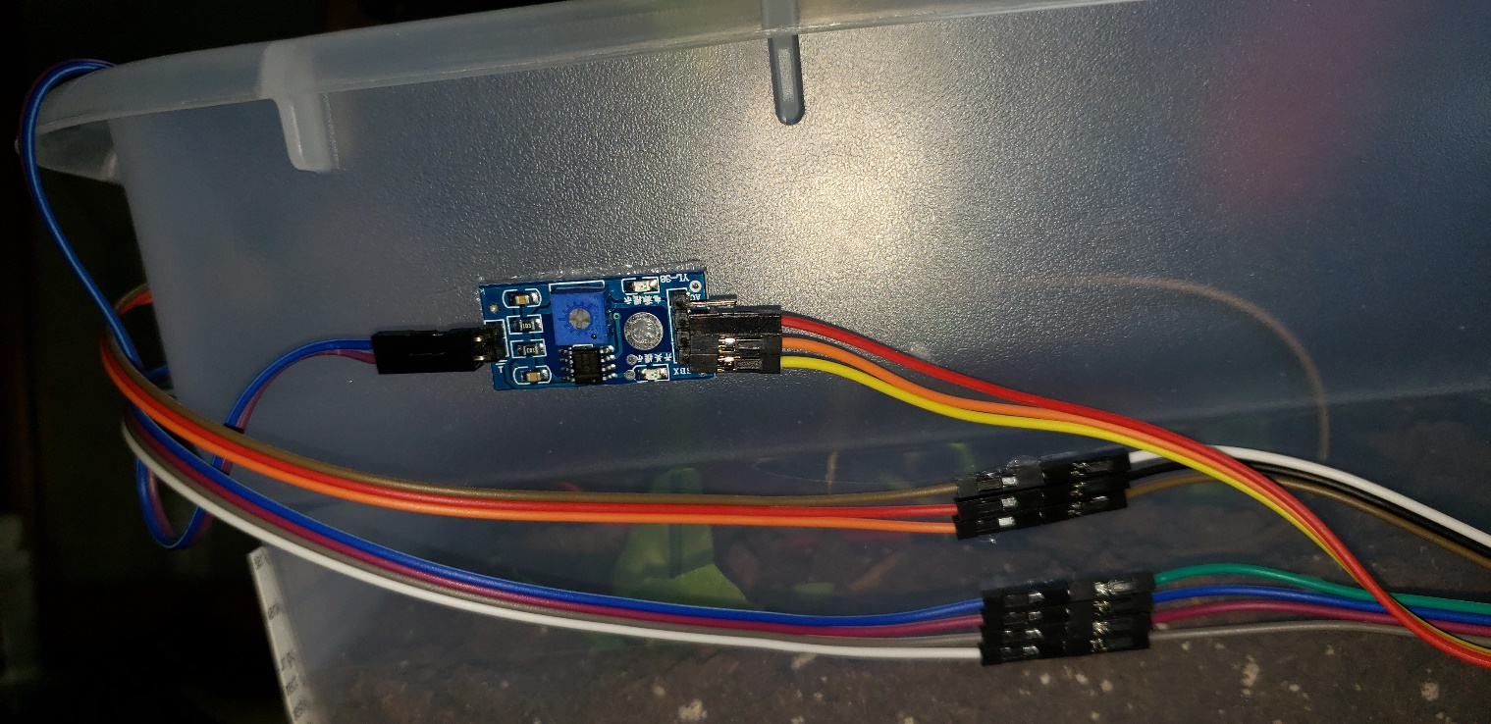

* Script:

Now, this Sensor is a little bit tricky.

This works in two ways:

1st: When the moisture/water is present in the soil.

In this case, Our sensor will bypass all the script writing and update the Google Cloud Service Firebase database, with the string **“Hurrray!....Plants have Enough Water. Will See you in 6 Hours”**.

Then your script will run in 6 hours and at that it will follow same procedure if the sensor will detect the water in the soil.

2nd: When the water content is not present in the soil.

In this case, first soil sensor will detect the water content in soil and if there is no water in soil then it will tell the script that the soil does not have appropriate amount. The script will then give the digital signal HIGH to the relay which is connected to the Raspberry Pi via pin number 33 i.e. GPIO 13.





Now the relay will turn on the water pump while the script will keep an eye out for the soil moisture sensor to give the signal that soil have enough water. During this process the script will update the Firebase database with the string to tell the user that “**No water detected…Turning ON the water system”**. Once soil sensor detects that it has appropriate amount of water in soil, it will turn off the pump and updates the Google Cloud Service Firebase database with the string the **“Hurray!...Plants Are Saved and Your next run for this script will be in 6 hours.”**

* Android App Screen Shots:

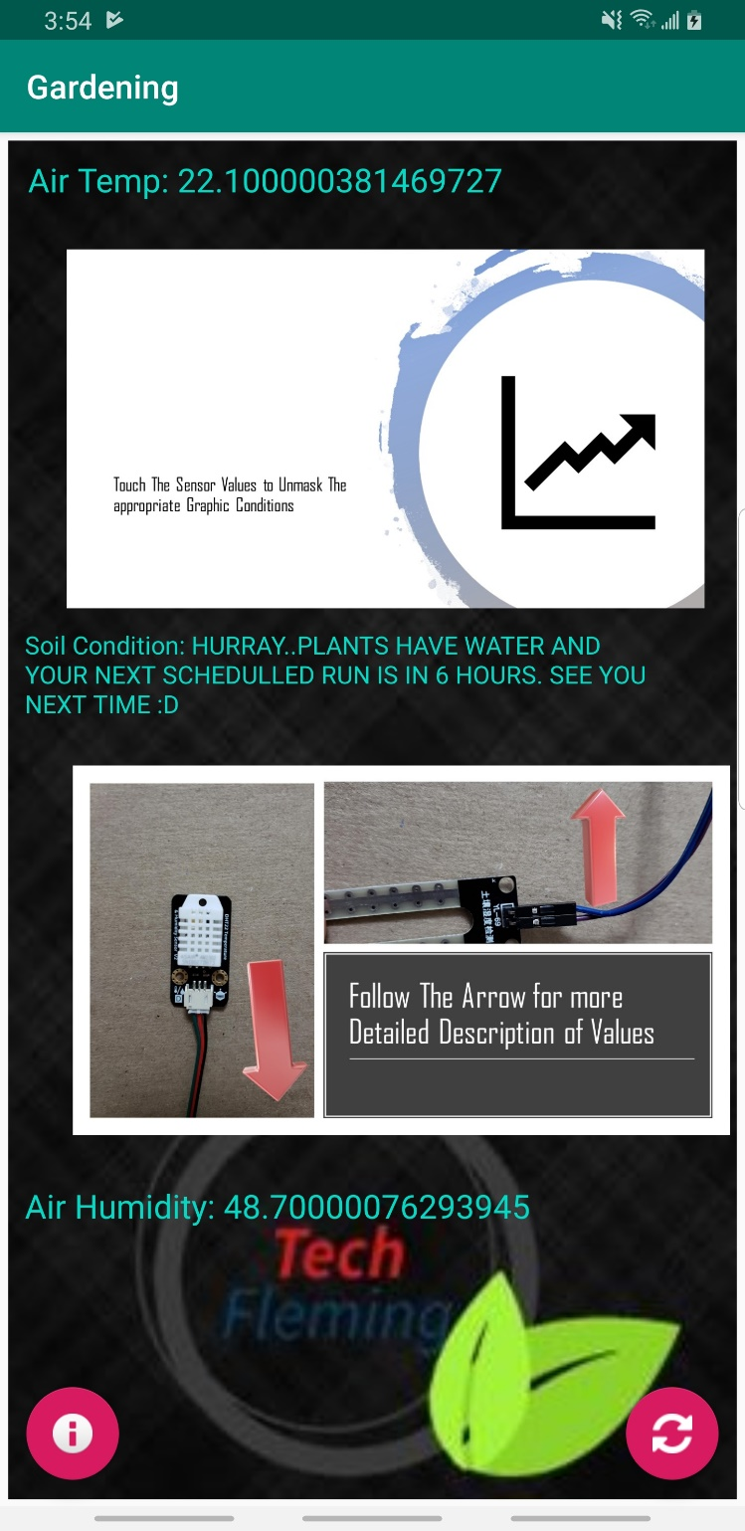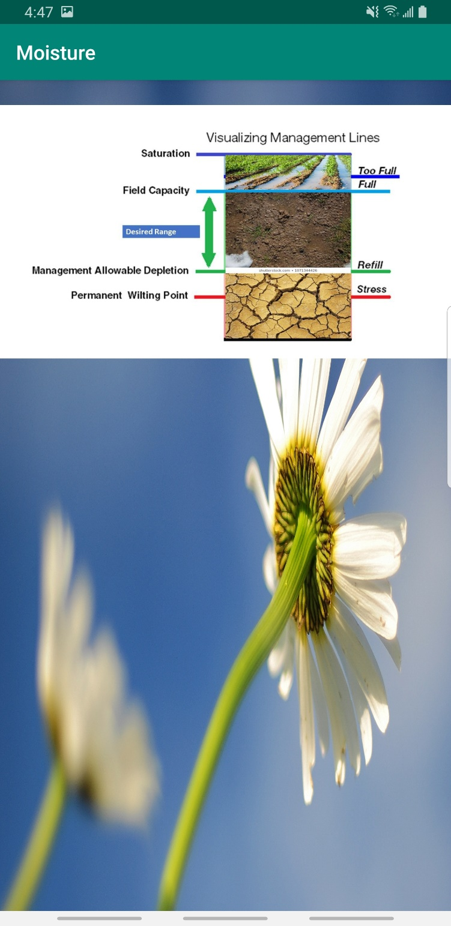

|  |
| --- |
| Raspberry Pi Camera Module |

* Image:

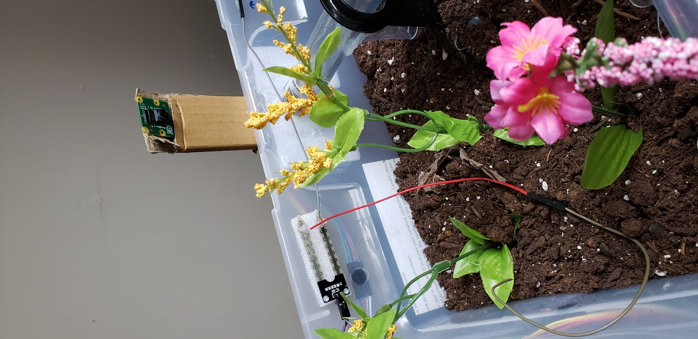

* Circuit Diagram



* Working

Camera Module is a very easy to setup, plug and play kind of thing.

Raspberry pi has an inbuilt library for this module. There are approximate 30 to 40 commands which can manipulate the camera according to user.

One can use:

Still images, hyper lapse, night vision, can resize image, use less or more pixels, low light mode, record a video, stream video and many more.

* Script
* Garden Picture

|  |
| --- |
| Water Pump |

* Image

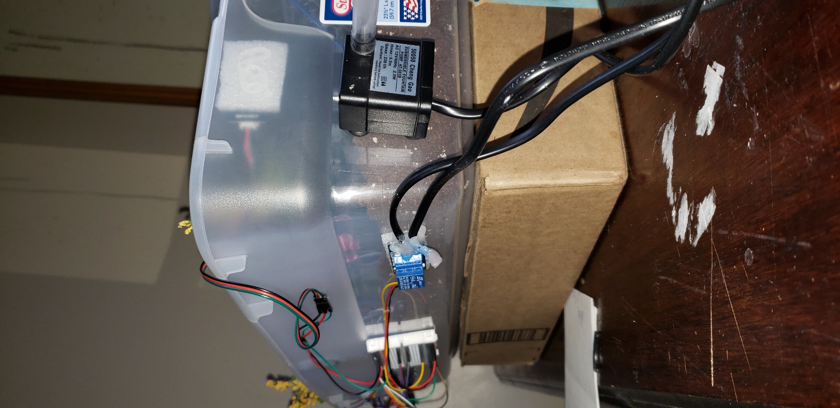

* Circuit Diagram

The positive terminal from power supply and pump are supplied through the relay and negative terminal are normally connected. When the relay is powered ON by the Raspberry Pi through digital signal, the two positive terminals are connected and turns ON the pump.

* Working

The pump works on the 12v power supply. It is fully submersible in the water.

|  |
| --- |
| Prototype Garden Box |

* Image

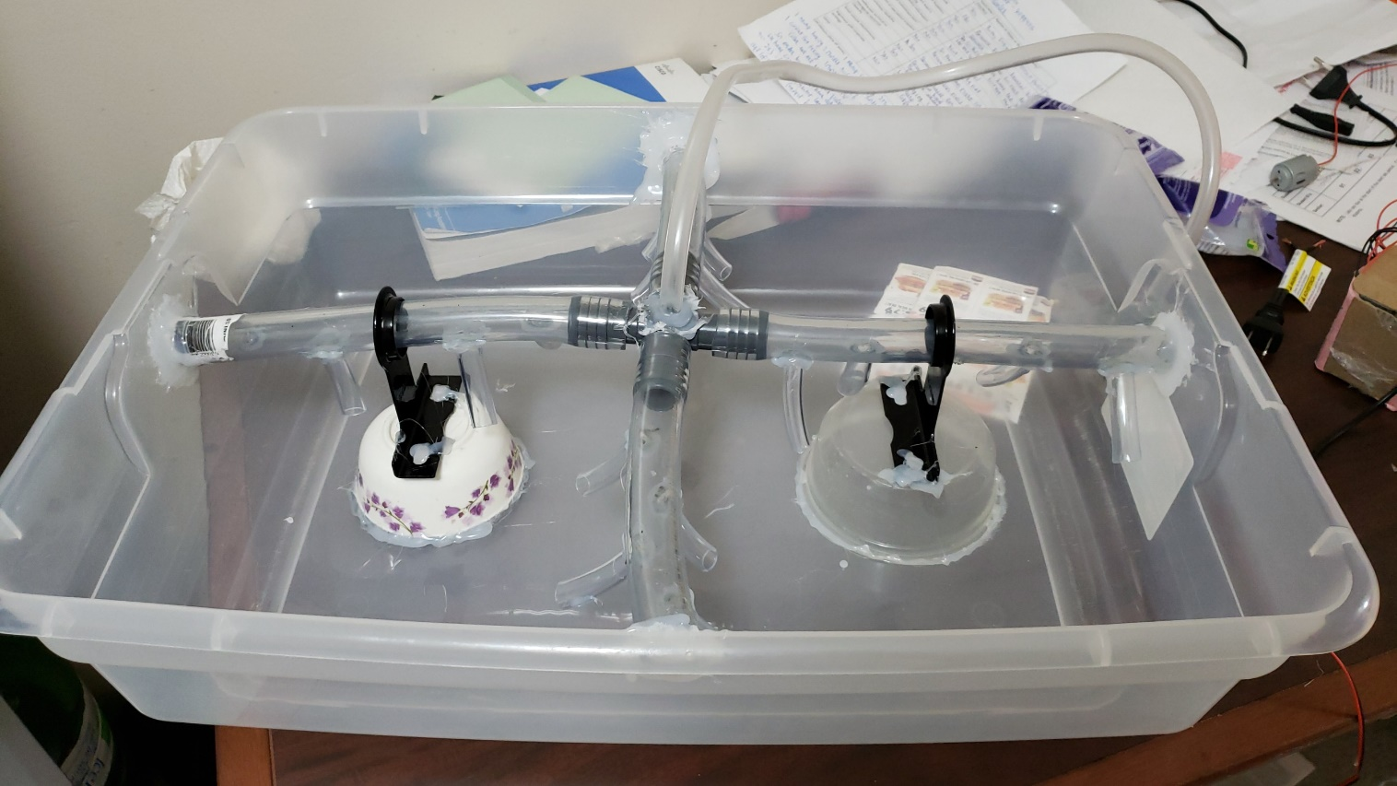

* Dimension

This prototype garden box is of 60 cm L X 42 am B X 15 cm H. This box perfectly complements the mini indoor gardening condition. We can actually grow small plants in this box. This box have perfect depth as compared to the roots for the small plants.

* Water Dispersion System

We have used an advance water dispersion system in our garden which is known as **Drip Irrigation System**.

In this water system water can be manually directed to the different corners of the box so that every seedling can be watered equally. There are directive nozzles in the box for water dispersion.

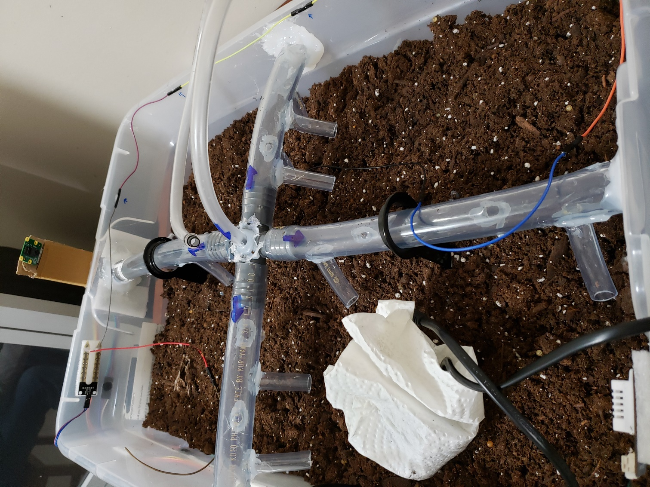

|  |
| --- |
| Relay |

* Image

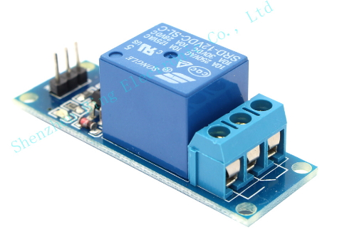

* Circuit Diagram

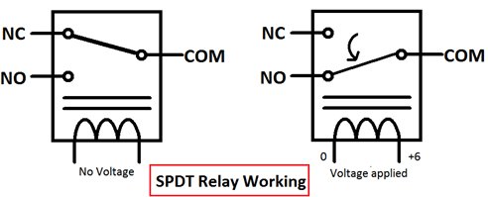

NC = Normally Connected i.e. this joint is normally connected to the load line.

NO = Normally Open i.e. it is normally not connected to the load line while offline.

COM = Common i.e. This pin is connected to the positive terminal.

* Wiring Diagram

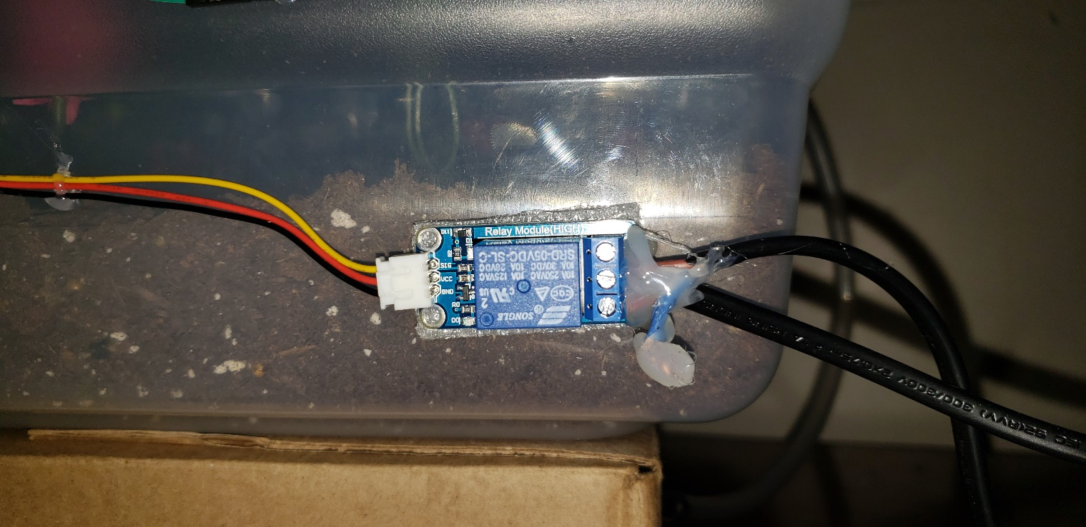

Left circle gives you the connection with the raspberry pi i.e. Vcc, Gnd, SIG.

Right circle gives you the connection with the pump sealed with the glue gun.

* Working

Relay is really like a switch between the connected load lines. We can manually switch ON or OFF the relay based on the digital signal. Relay opens or closes the connection between load lines if applied with voltage.

We connect the positive of the appliance which we want to control to the COM port of the relay and connect the other half of the positive to the NO port of the relay. Now, when we power the relay with the digital signal from RPi, relay connect the COM port from NO to NC which turn ON the appliance.

|  |
| --- |
| POLY VINYLE PIPES |

* Image

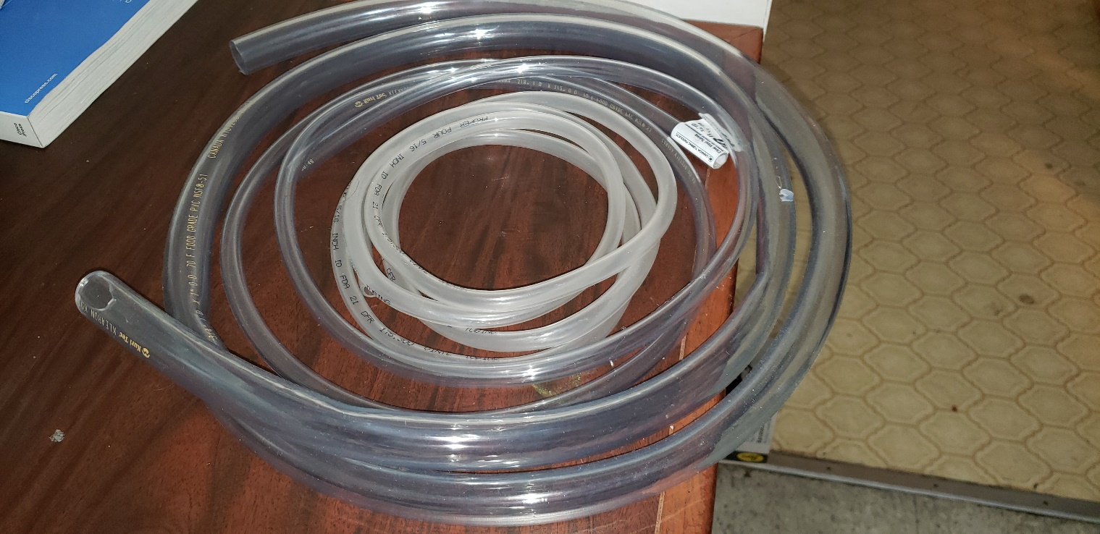

* Reason for their use

Theses vinyle pipes are food grade which can withstand the temperature of 50 to -45 *c. They are flexible to work with and are easily bendable. That’s why we have used support rings in the garden box so that they won’t clog water in them.